# 4 Introduction:

This chapter is related to project scheduling which describes what are deliverable, when they submitted to the supervisor and what methodology adopted to accomplish the task.

**Project Deliverables:**

The list of project deliverables is:

* Project Management Plan
* Software Requirements Specification
* Software Design Description
* Software Quality Assurance Plan (including the Software Verification and Validation Plan and the Test Design Document)
* Working System with Relational Database Design
* Final Thesis Document

**Schedule and Budget Summary**

**Budget Summary**: “No budget required”.

**4.1 Planning:**

The detailed plan designed prior to project development is as follows:

**4.2.1 Work break Down Structure:**

System Development

Test Case Development

Database Design

UML

ERD

Use Cases

Non Functional Reqments

Functional Requirements

Project Proposal

Project thinking

Requirement Gathering

Coding

Testing

Design and Analysis

Project Planning

Events Management System

**Figure 1: Work Break Down**

**4.2.2 Project Schedule:**

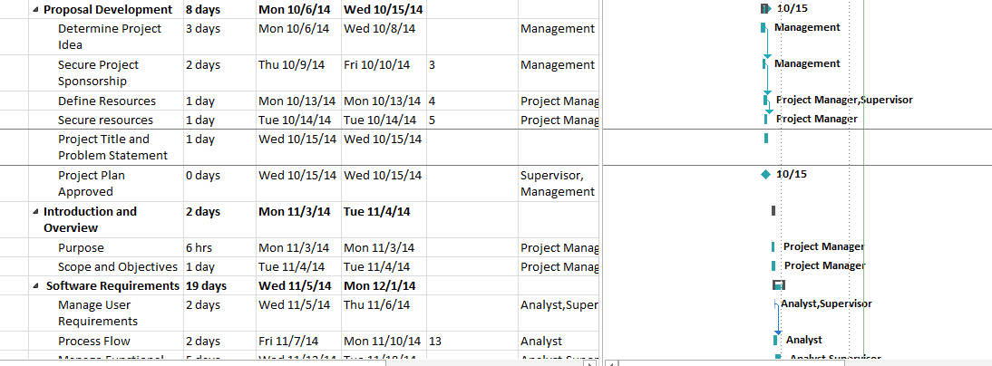

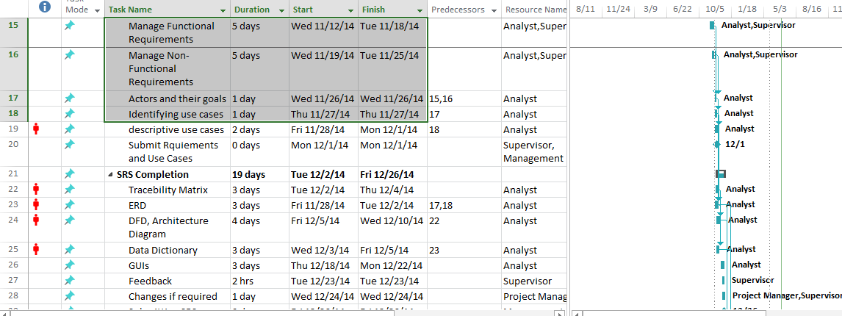

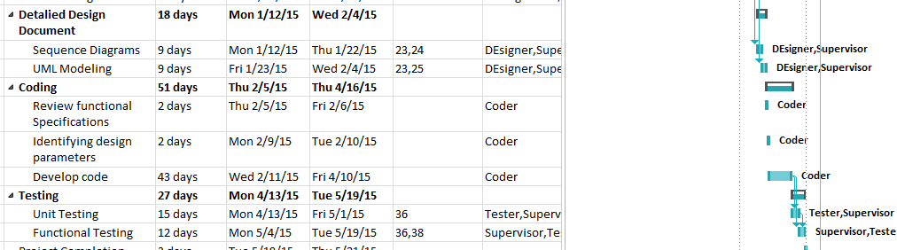

**Figure 2: Project Schedule**

# 4.3 Methodology:

The well-known **‘Waterfall Model’**has been adopted for this. The main reason behind selecting this model is that development is done in phases. Large systems require proper analysis before it is developed and implemented. Such systems are critical and no error of failure shall be tolerated once they have been developed and deployed. So, to ensure that system is developed properly and testing is successful, it is important that on each step of its development proper analysis has been done.

Typical steps in Waterfall Model include:

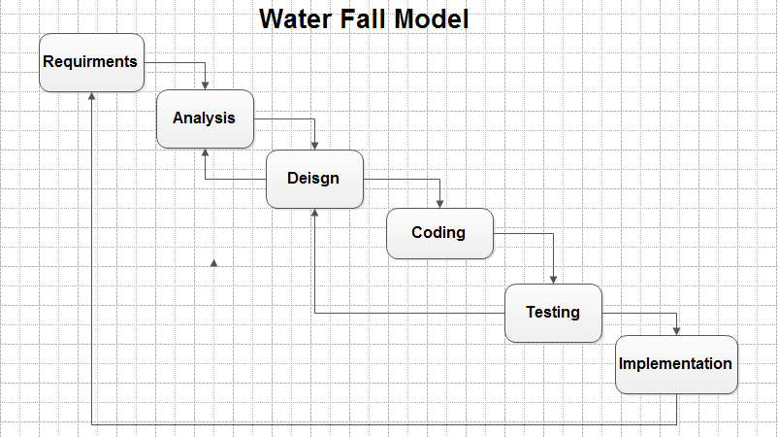

**Figure 3: Process Model**

## Requirements:

When changes are to be made in the requirements after the SRS has been released, the changes brought into the attention of the committee and discussed. Any changes that are to be made, with the prior approval of the committee and only if feasible and permissible within the constraints of the project, and resources in terms of knowledge and skill of the developer required. Once the changes made to the SRS document, an updated version of the SRS released and circulated to the committee. However, no changes were made to the requirements when the software design document (SDD) completed.

## 4.3.2 Analysis:

Extra time was spent on analysis by meeting with different users to understand the requirements completely. Most of documentation phase completed in P1. During this time period knowledge about development tools were gathered to future easiness.

## 4.3.3 Design:

Designing had been done prior to development. GUIs, Use-Case, Sequence Diagrams, System Architecture, Entity Relationship and Class Diagrams had been designed and made part of SRS and Detailed Design Document as mention in next chapters.

## 4.3.4 Coding:

A coding is a part of the algorithm developed using recommended departmental standards.

## 4.3.5 Testing:

In this phase, I validate all the main functionalities of this system and write test cases behind each functionality which are pass and fail.

## 4.3.6 Implementation:

In this phase I implemented my system and see the result that which requirements are completed and which is not. This phase is also deployment of system.